

**Consignor Packet**

Provided by the Little Lambs Consignment Committee

**Sale Information**

Thank you for your interest in consigning with Little Lambs Consignment Sale! We are sponsored by First United Methodist Church of Tuscaloosa. Consignors receive 70% of sales proceeds and First United Methodist Ministries receive 30%. A $5 consignment fee will be assessed from your earnings. This helps us continue to provide the best services possible during the sale.

**General Information**

Anyone can consign with Little Lambs. We accept a total of **175 consignors**. Only one consignor spot per household will be allowed. Consignors must have at least **50 items** and a maximum of **125 items**.

**We gladly accept:**

* Spring & Summer children’s clothing sized **Newborn – size 14** (no Junior sizes)
* Children’s shoes sized NB to big kid size 7 **(limit 8 pair of shoes per household)**.
* Dress up costumes
* Children’s Accessories (tights, pantyhose, socks, hats, belts, purses, backpacks, etc.)
* Indoor and Outdoor Toys
  + All items requiring batteries must have working batteries installed
* Books
* Videos and DVDs
* Baby Gear (car seats, play yards, swings, high chairs, strollers, bouncy seats, diaper bags, etc.)
  + All items requiring batteries must have working batteries installed
* Children’s furniture (bassinets, toddler beds, changing tables, dressers, gliders, tables, chairs, book shelves, etc.)
* Children’s and Nursery Décor
* Safety Gear (gates, bedrails, latches, etc.)
* Maternity Books and Parenting Books

**We do not accept:**

* Fall/Winter Clothing and Accessories (coats, sweaters, winter boots, etc.)
* Stained, Soiled, Damaged Clothing: Items which have stains, are soiled, are faded, badly worn, have strong odors, tears, missing buttons or snaps will be returned to the seller at check-in.
  + We reserve the right to pull any item and return to the seller after check-in should it be found to be stained or damaged.
* Clothing with drawstrings around the neck
* Underwear and Bras – unless new in package
* Cribs manufactured before June 2011.
* Car Seats more than five years old
* Recalled items. To see if an item is ok to sell, send an email to *recallslittlelambs@gmail.com* and include the item, description, manufacture date, and any identification numbers.
* Sippy Cups, Baby Bottles, Pacifiers, or feeding gear – unless new in package
* Stuffed Animals
* Toys that are damaged or are missing pieces

**Preparing your items for Consignment**

*Clean, wash and make it shine!* The nicer your items look, the quicker they will sell. If you think a toy could you a scrub down before you bring it, give it a scrub. A quick touchup with the iron makes a huge difference in presentation and how your clothing will sell.

**Clothing**

* All tags must be printed using the format provided on the mysalemanager website accessible from the church’s website http://fumct.org/ministries/little-lambs Tags must be printed on **white** cardstock paper. Items with handwritten tags, or tags printed on plain computer paper will not be permitted.
* Clothes should be placed on a hanger; the hook should be facing left so it makes a question mark.



* Tags should be pinned to the right side when looking at the front of the garment (see picture)

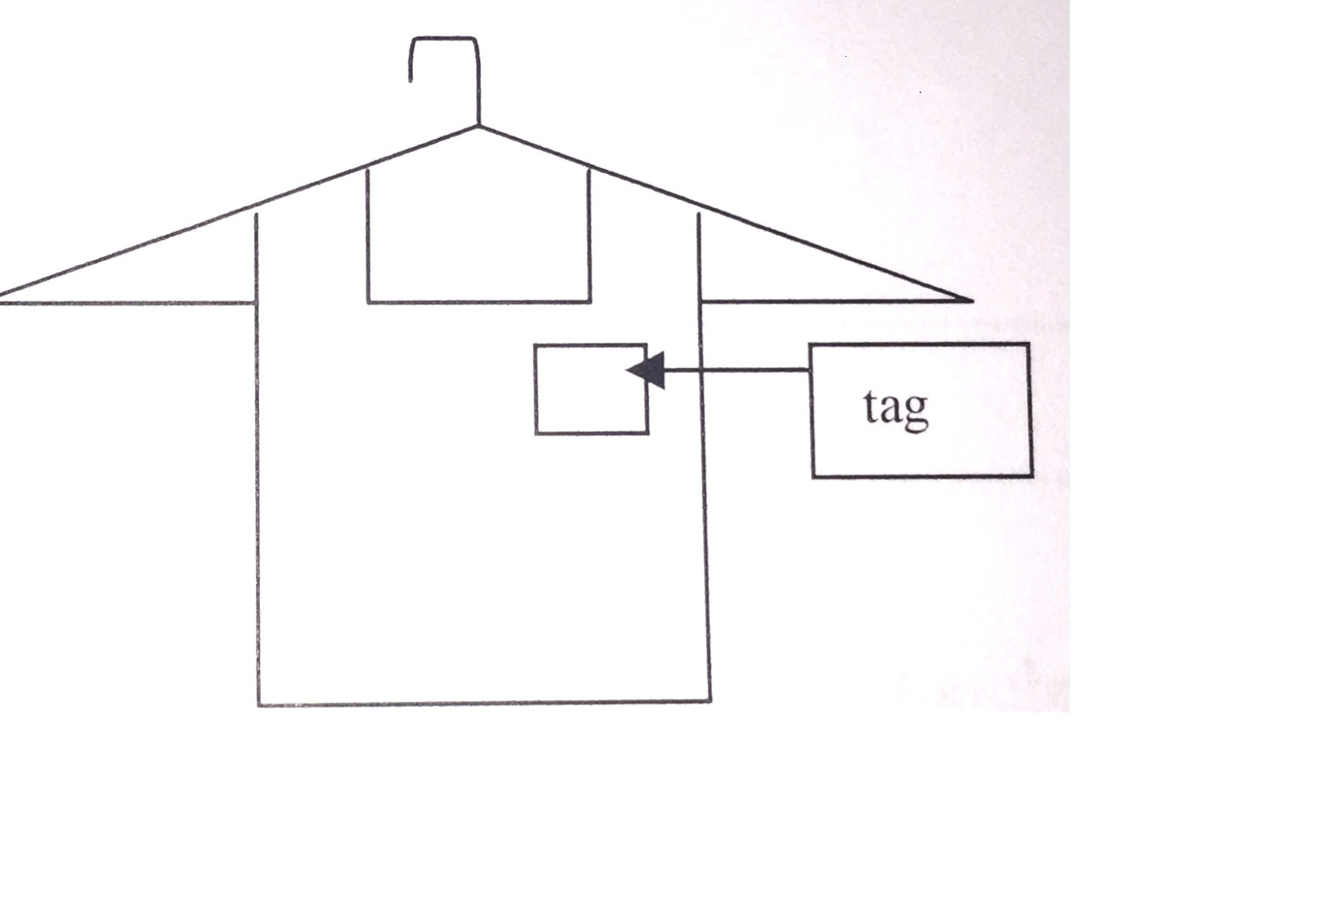

* Pants can be hung with a pant-clip hanger, or pinned on a regular hanger through the waistband.
* Safety pins are the only acceptable method for placing tags on your clothing. Tagging guns, staples, and tape are not permitted.
* All clothes including onesies, pajamas and other sleep-wear must be on hangers.
* If you are selling multiple clothes together as an outfit or lot (ex: multiple onesies), rubber band the neck of hangers together, or pin to the back the additional items.

** Pieces of sets often lose their partner, therefore it is recommended to label each piece of a set with your consignor number and item number.

* Items not properly hung must be re-hung before they can be accepted.

**Non-Clothing Items**

* Shoes: shoes are funny in that one likes to walk away. Keep them together with a zip tie or tied together with the tag attached. Do not bring shoes in boxes. If using a Ziploc bag, tape the tag to the outside of the bag. Be sure not to tape over the barcode.
* Toys and Equipment: Place any accessories in a Ziploc bag and attach it to your item with a zip tie or clear packing tape. Please use zip ties to secure your tag on any item that could be damaged by tape. Batteries must be included in all battery-operated items.
* Accessories: blankets, swaddle blankets, lovies, etc., should not be placed in Ziploc bags. If selling multiples together, please pin together as a group. These items will be examined for stains like clothing.

**Sort Your Items**

* Categories: Items should be sorted by category: Boys, Girls, Nursery Items, Toys, etc.
* Size: Within each category, sort your items by size from smallest to largest
* Accessories: Within each category, include your accessories after your clothes
* Example Sort:
  + Boys Pants size 3 months
  + Boys Shirt size 12 months
  + Boys tennis shoes size 1
  + Girls Dress size 2T
  + Girls Shirt size 7
  + Bag of girl hairbows
  + Bouncy Seat
  + DVD: Veggie Tales

**Pricing your Items**

*How much would* ***you*** *pay for it?*

* Be conservative when pricing your items so they will sell quickly.
* A good rule of thumb is 1/3 of their original sale price for excellent condition, and ¼ of their original sale price for good condition.
* When pricing clothes, remember we receive many items in the 0 – 24 months range. To be competitive, try selling multiple items together.
* Items must be priced at $1 or above in whole number increments.
* We recommend marking your items for the half-price sale.

**Consignor Tips**

* One inch or larger safety pins work best when securing tags.
* Clearly identify your item when writing the description on the tag. This helps us match a lost tag during the sale (ex. Gymboree yellow plaid dress)
* Questioning if one of your items has been recalled? Check your items at www.cpsc.gov. Don’t forget to email the Little Lambs Recall committee at *recallslittlelambs@gmail.com*
* When printing tags, be sure your printer is **not** set to “Fast Draft” or “Econo-Mode.” In the past, tags printed that used less ink were not readable by the barcode scanners.

** New Ink Cartridges do tend to cause the barcodes to run which makes the barcode un-readable with the scanner.

**Using Mysalemanager**

***Inventory must be entered by Sunday, April 18 @ 6:00 pm.***

*Entering Items*

1. Connect to the mysalemanager webpage from http://fumct.org/ministries/little-lambs
2. Click Consignor Inventory Entry and Tag Printing
3. Type in Consignor Number and Password (you created this when you first registered as a consignor) and click Login.
4. Click on Work with my Consigned Items (Active Inventory)
5. Begin Entering Tags. *Remember tags can only be printed on white cardstock paper.*
   1. Category: click the arrow for a drop-down list and highlight the category your item should be listed under
   2. Size: click the arrow for a drop-down list and select the size for the item. ***Remember that S, M, and L should not be used. Please assign a numerical value for each piece of clothing. Clothes not following this procedure will not be accepted.***
   3. Description Line 1: Enter a description for your item. Be as detailed as possible including brand, color, design, etc.
   4. Description Line 2: additional room for more description. We use this information to search the inventory system should a tag become separated from an item.
   5. Price: enter your price to sell in whole dollar amounts
   6. Quantity: Enter how many items you have
   7. Check to Discount: Click this box if you want your item to be half-price at the sale on Saturday. Failing to check this box indicates your desire to **not** discount items on Saturday.
   8. Check to Donate: Click this box if your item doesn’t sell, and you want to donate the item to charity.
   9. Submit Item: Once you click this box your item will appear in the inventory list below
   10. I’m finished for now: Clicking this will save your current inventory for access at a later time.

*Printing Tags*

1. Load your printer with **white** cardstock. Remember that tags printed in any other color cannot be accepted because of the sensitivity of the barcode scanners.
2. Click on Inventory Entry and Tag Printing
3. To Print All Tags: click on Print All Tags.
4. To Print Selected Tags: click on Print Selected Tags. Check each box on the tags you want to print and then Print Selected Tags.

** New Ink Cartridges tend to cause the barcodes to run which makes the barcode un-readable with the scanner.

*Printing Inventory Report*

1. Load your printer with **regular** computer paper.
2. Click on Consignor Inventory Entry and Tag Printing
3. Click on View/Print Inventory Report
4. ***Be sure to bring a copy with you to check-in. You will not be allowed to check-in without an inventory report.***

**Check-In Instructions**

1. Sign-up for a check-in time via mysalemanager
2. Come approximately 15 minutes prior to your scheduled check-in to unload items and organize them by category.
3. **Bring your completed inventory sheet!** We keep the original copy of your inventory sheet. Your final reconciliation listing which shoes which items were sold full price, half price, and returned will be available at the conclusion of the sale.
4. Please allow 15 – 45 minutes to drop off your items as they will be inspected for adherence to the previously stated guidelines. Please do not be offended if something is returned to you. We strive to provide the highest quality merchandise to our shoppers.

**Merchandise and Check Pick-up Instructions**

* All items will be sorted and ready for pick-up after the sale.
* You must pick up checks and all unsold items by Saturday at 4:00 pm. If you cannot pick up your unsold items during this time, please make arrangements for someone to pick them up for you.
* **Any items left past 4:00 pm on Saturday are immediately donated to charity.** After 4:00 pm the items are no longer at the church and we cannot get anything back.
* Checks not picked up on Saturday will be mailed to the consignor. *Be sure your address is correct in mysalemanager!*
* Lost Items: if a tag is separated from its item, and the match cannot be found, the item and/or tag will be placed in a lost tags/items section close to the front doors of the gym. You are responsible for checking this section during pickup to ensure none of your items are left at the sale. Any item remaining in the lost items section after 4:00 pm on Saturday will be donated.



Volunteer Information

Provided by the Little Lambs Consignment Sale Committee

Volunteers are the heart and soul of the Little Lambs Consignment Sale. We could not have a successful sale, which in turn benefits First United Methodist Church’s Ministries without our volunteers. By volunteering, you will not only get to wear one of our fabulous green smocks, but also have the opportunity to receive shopping benefits! Free childcare is offered to anyone volunteering for a weekday shift and Saturday. Thank you in advance for serving at the Little Lambs Consignment Sale.

* By working 1 shift, you can shop at 4:00 pm prior to the public on Thursday.
* By working 2 shifts, you can shop at 3:00 pm prior to the public on Thursday.
* Consignors can shop at 5:00 pm on Thursday.
* Public can shop with $5 admittance fee (no strollers) at 6:00 pm on Thursday.

To sign up to volunteer:

1. Connect to mysalemanager via the church website http://fumct.org/ministries/little-lambs
2. Select Volunteer Worker Registration and select the shifts you would like to work
3. To register for childcare, go back to the main page on the church’s website (see #1), and select at the very bottom of the page, Click Here for Volunteer Childcare Registration



**Sale Dates & Hours**

Provided by the Little Lambs Consignment Sale Committee

**Thursday, March 11th**

9:00 pm Consignor and Worker Registration Open via http://fumct.org/ministries/little-lambs

**Sunday, April 21st**

6:00 pm System Shutdown. All inventory must be entered

**Tuesday, April 20th**

3:30 pm – 8:30 pm Consignor Check-in

**Wednesday, April 21st**

9:00 am – 8:00 pm Consignor Check-in

**Thursday, April 22nd**

3:00 pm Volunteers working 2 or more shifts pre-sale

4:00 pm Volunteers working 1 shift pre-sale

5:00 pm Consignors pre-sale

6:00 – 8:00 pm Public sale with $5 admittance fee (no strollers)

**Friday, April 23rd**

9:00 am – 6:00 pm Public Sale

**Saturday, April 27th**

8:00 am – 8:45 am Saturday volunteers may shop the half-price sale

9:00 am – noon Public Half Price Sale

3:00 – 4:00 pm Consignor check pickup and unsold items pickup